EASO publishes two new country guidance notes on Iraq and Afghanistan

* 4TH JULY 2019

***EASO has published the***[***‘Country Guidance: Iraq’***](https://www.easo.europa.eu/sites/default/files/Country_Guidance_Iraq_2019.pdf)***and the updated***[***‘Country Guidance: Afghanistan’***](https://www.easo.europa.eu/sites/default/files/Country_Guidance_Afghanistan_2019.pdf)***. The documents reflect the common assessment of EU Member States of the situation in two of the main countries of origin for applicants applying in the EU. They are based on recently published***[***EASO Country of Origin Information Reports***](https://www.easo.europa.eu/information-analysis/country-origin-information/country-reports)***and provide a detailed analysis in terms of international protection needs and qualification in accordance with the applicable EU asylum legislation.***

The [‘Country Guidance: Iraq’](https://www.easo.europa.eu/sites/default/files/Country_Guidance_Iraq_2019.pdf) is the third country guidance document, produced since the pilot development was completed in June 2018. It adds to the series of tools for policy-makers and decision-makers, with a country-specific analysis regarding the main actors of persecution or serious harm in Iraq, refugee status and subsidiary protection needs of some of the relevant profiles of applicants from Iraq, actors of protection, and the possibility of internal protection alternative in particular parts of the country. Exclusion from international protection is also addressed.

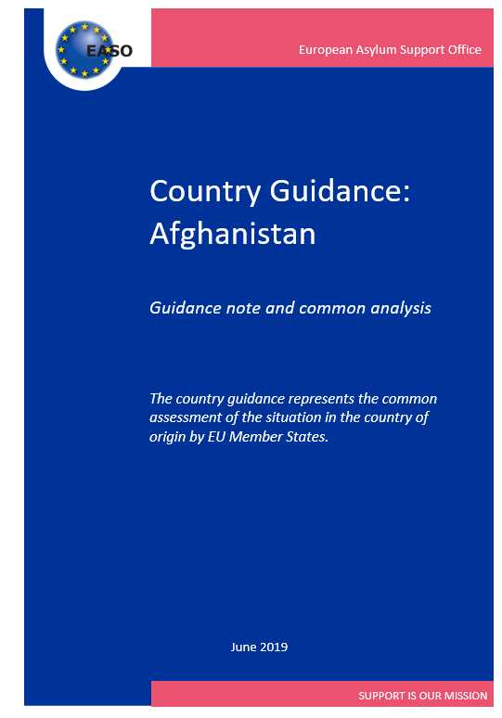The [‘Country Guidance: Afghanistan’](https://www.easo.europa.eu/sites/default/files/Country_Guidance_Afghanistan_2019.pdf) updates and replaces the pilot country guidance document, published in June 2018.

This update focuses on the sections concerning indiscriminate violence in a situation of an armed conflict (Article 15(c) QD), and internal protection alternative. Some additional changes have been made with reference to the available up-to-date country of origin information, in particular with regard to the profiles of applicants of Hazara ethnicity. Minor changes have also been introduced in parts of the horizontal framework of the common analysis. These changes do not generally impact the assessment of the situation in Afghanistan as per the previous version of the guidance from June 2018.

The [‘Country Guidance: Iraq’](https://www.easo.europa.eu/sites/default/files/Country_Guidance_Iraq_2019.pdf) and the [‘Country Guidance: Afghanistan’](https://www.easo.europa.eu/sites/default/files/Country_Guidance_Afghanistan_2019.pdf) are non-binding. Their aim is to assist in the examination of applications for international protection, and, ultimately, to foster convergence in the decision practices of Member States. It is Member States’ responsibility to examine each application for international protection individually, objectively and impartially, on the basis of the individual circumstances of the applicant and the situation in the country of origin at the moment of the decision.

For more information concerning this important area of activities, see <https://www.easo.europa.eu/country-guidance>.